How to update the firmware of Powerline Extender?
Step 1: Open bowser and enter plc.tendawifi.com in address bar to login the setup page.

Step 2: Choose “Administration” > “Device Management” > “Firmware Upgrade”. Tap “Upgrade” to upload the firmware.
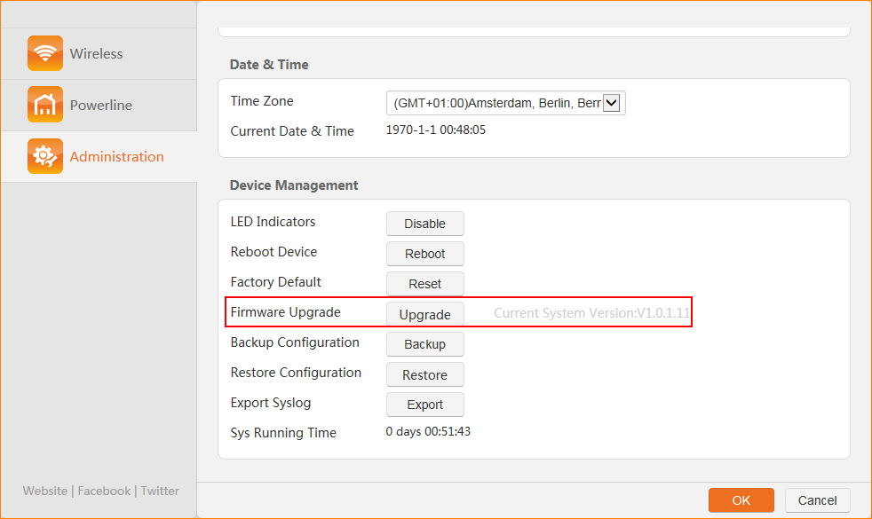

Note: Please reset the device after firmware upgrade is finished.

